RIPHAH INTERNATIONAL UNIVERSITY, ISLAMABAD


Assignment MS MPI
Bachelors of Computer science – 7th semester
Subject: Parallel and Distributed Computing

Submitted to: Ma’am Hajra Murtaza
Submitted by: Ayiza Waqar
Sap Id: 44529
Date: 1st January, 2025

MS MPI Downloads
The following are current downloads for MS MPI:
Download Microsoft MPI v10.1.3 from Official Microsoft Download Center
Download MS MPI execution file and Sdk
Requirements:
Visual Studio ( with C++ Distribution)
MS MPI , SDK
Steps for running a MS MPI Program on two nodes
- Create a New C++ project
- New Project -> Windows Desktop Application
The name of the project and files should be the same for two machines.
- Write a Basic program of MS MPI which displays total processes, the current running process and processor name
Here is the code:
Insert code in c++ file:
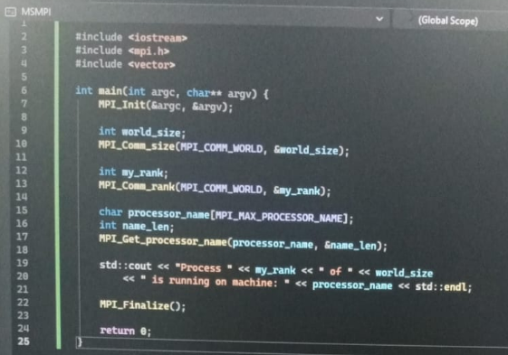
Add paths of MS MPI in project properties as given below:
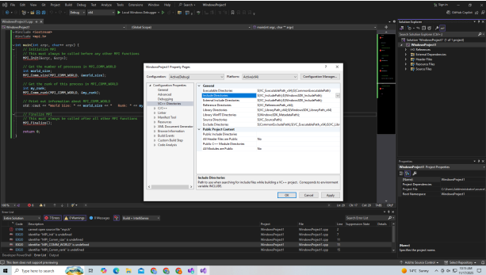
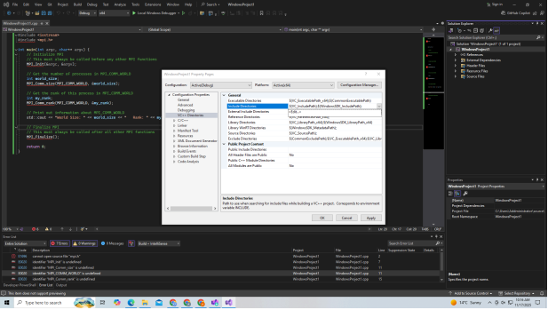
- These are the paths (verify installation by checking the folder directory)
C:\Program Files (x86)\Microsoft SDKs\MPI\Include
C:\Program Files (x86)\Microsoft SDKs\MPI\Lib\x64
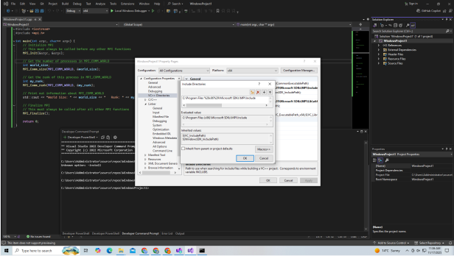
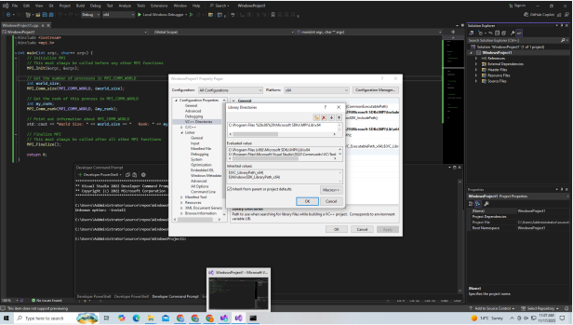
- In Additional directories insert
msmpi.lib
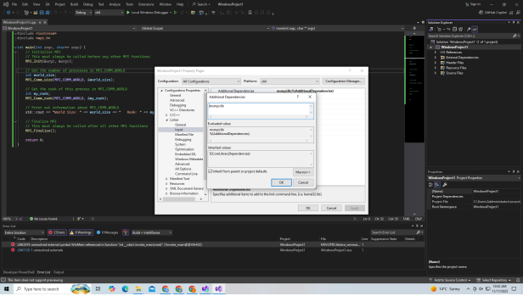
In linker systems, choose subsystem and from dropdown select subsystem console:
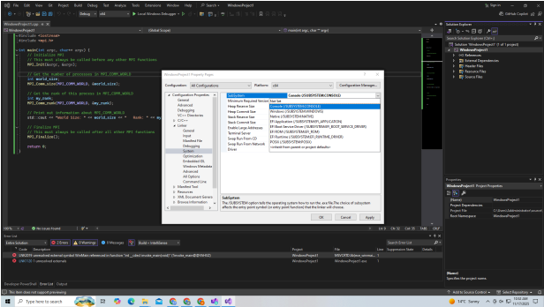
- Execution Command:
Mpiexec -np 4 MSMPI.exe
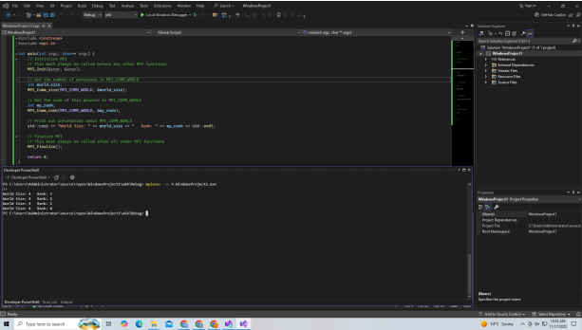
By using Command prompt (Administrative), turn off firewall.
Command:
netsh advfirewall set allprofiles state off
Note: Smpd is a cluster process manager
For running on multiple machines, two machines should be logged in the same accounts or should do smpd settings.
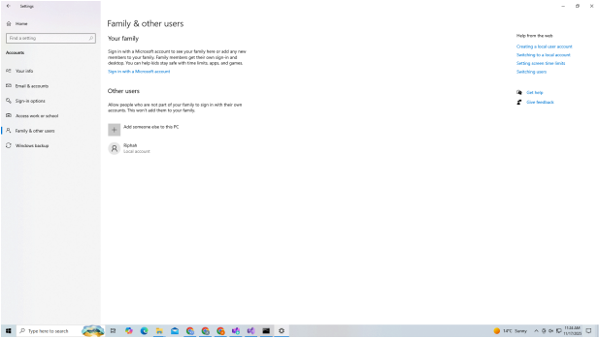
Use ping command to check connection:
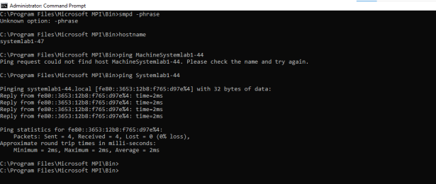
Create a machine file (txt) to run it on multiple machines, Add machines host names e.g systemlab2-21
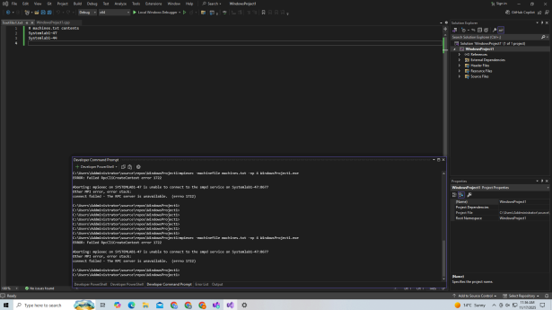
Command for starting smpd settings on all machines.
cd "C:\Program Files\Microsoft MPI\Bin"
start smpd -d
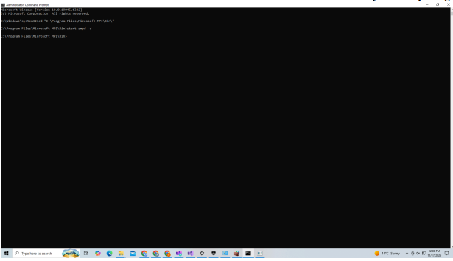
Command for execution using different machines
Mpiexec -machinefile machines.txt -np 4 MSMPI.exe
